Services Offered
- Direct Marketing Agency – PIC
We are working as Direct Marketing Agency.Direct marketing is a promotional method that involves presenting information about your company, product, or service to your target customer without the use of an advertising middleman. It is a targeted form of marketing that presents information of potential interest to a consumer that has been determined to be a likely buyer.
Our Services in Direct Marketing Includes: Brochures, Catalogs, Fliers, Newsletters, Post cards, Coupons, Emails, Targeted online display ads, Phone calls, Text messages
Direct marketing occurs when businesses address customers through a multitude of channels, including mail, e-mail, phone, and in person.

Retailers, credit card companies, media companies, technology companies, non-profit organizations—nearly every business uses some amount of direct marketing.

Direct marketing is a type of advertising campaign that seeks to achieve a specific action in a selected group of consumers (such as an order, store or website visit, or a request for information) in response a communication action done by the marketer. This communication can take many different formats, such as postal mail, telemarketing, point of sale, etc. One of the most interesting methods is direct email marketing.

An essential aspect of direct marketing is that the consumer response is measurable: for example, if you offer a discount for an online store, you should include some kind of cookie or pixel to let you know if the user has used of the code.

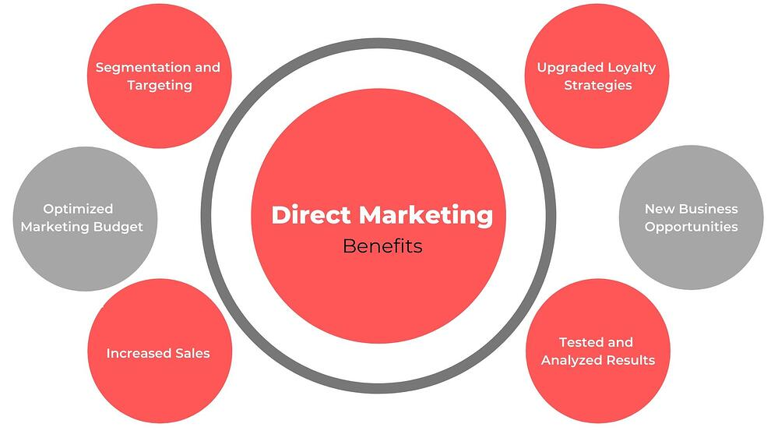

- GIS – Global Information By state –Online , Offline

Pandya Software GIS clients and developer SDKs will progressively add support for the sync capability in feature services, which was introduced in GIS new concepts. The first clients to support working with maps while offline and using the sync capability to synchronize changes are GIS Collector and GIS Runtime SDK. You cannot enable the sync capability on feature services published prior to GIS new version.
- ROU – Right Of Using (Pipeline Digitization)
Safe Pipeline transportation of energy resources is a major concern. Every Natural Gas Pipeline Operator’s primary objective is to operate and maintain pipeline network in such a way that it would continuously provide un-interrupted services to customers without any accidents which can adversely impact on the environment and reputation of the organization. Various surveillance methods are being used in Natural Gas Pipelines as a part of direct integrity assessment. Traditionally, surveillance is conducted by line walking and supplemented by vehicular over the linear corridor. This process involves various shortcomings in terms of efficacy, accuracy, cost, and safety. This method purely depend upon Inspector’s ability for detecting anomalies. It is in the interest of any operator to maintain the value of its pipelines and to protect them effectively against damage caused by third parties. As a result of global progress in high-resolution remote sensing and image processing technology, it is possible to use digital surveillance method for monitoring of pipeline Right of Use (RoU). Digital Surveillance is done using Remote Sensing and Geographical Information System (GIS) techniques. Remote sensing based pipeline surveillance refers to the monitoring and detection of changes on RoU and around pipeline networks. This paper elaborates on the development and implementation of a digital solution that uses images from satellites and Unmanned Aerial Vehicles (UAV) to detect instances of encroachments and third-party activities on Pipeline RoU. Such a solution provides capability of running advance analytics on captured images, and will enable to automate detection of anomalies which may often go un-noticed during manual inspection.

- Data Entry & Digitization – PIC

Digitization Scanning, Data Entry OCR, ICR etc
With the drastic increase in different types of data with numerous formats, the need to integrate and share data across systems has become vital. Two of the many benefits of digitising your paperwork are; A much quicker document search and retrieval system and reduction in physical space requirements.
Scanning and Digital Imaging is the conversion of physical documents and images of all kind, in any format, into their digital equivalents. It reduces the requirement of physical space and provides much quicker document search and retrieval. RVS provides total digitizing solutions and targets for operator-friendly design and productivity. We mainly focus on client-specific document management requirements so that we can offer you effective solutions keeping present and future needs in mind.

Following are the main features of Digitization:

Streamline business processes:
- Improve productivity and efficiency.
- Optimize processing time.
- Streamline paper-based processes.
- Deliver Data/Information to the right person at the right time.

Document Management:
- Management and Archival of documents in a structured and secure manner.
- Protection of your paper records.
- Reduces risk of lost or misplaced documents.

Data Capture:
- Record information from paper documents, digital content and multimedia.
- Transform and deliver the captured information into various systems: CRM, ERP, Document Management, MIS, etc.
- Read Information from scannable inputs like QR codes, barcodes, RFID chips.

Continuous Availability:
- Keep end users connected to their mission- critical applications.
- Not just LAN based; WAN-enabled.
- Provision of robust high availability and disaster recovery solutions.

Its other features are:
- Minimize Paper Storage
- Increase Information Security
- Eliminate Manual Searches
- Enhance Customer Service
- Improved Information Availability – Multipoint access

Data Entry OCR (Optical Character Recognition):
Optical character recognition (OCR) sometimes also called as optical character reader, is the mechanical or electronic conversion of images of handwritten, printed text or typed into machine-encoded text. It is broadly used as a form of data entry from printed paper data records, whether printouts of static-data, bank statements, invoices, passport documents, business cards, mail, or any suitable documentation. It is a common method of digitizing printed texts so that data can be electronically searched, edited, stored more compactly, and used in machine processes such as text-to-speech, machine translation, key data and text mining. OCR is a field of research in artificial intelligence, pattern recognition and computer vision.
Early versions required to be trained using images of each character, and worked on one font at a time. Our advanced system has capability of producing high level of recognition accuracy for mostly all fonts which are common now. Our system has capabilities of reproducing formatted output that closely resembles the original page including columns, images, and other non-textual components. We have upgraded our OCR system to work as an ICR (Intelligent character recognition) which is more efficient in the same work.

Following are the step-wise techniques used in OCR:
- Pre-Processing
- Character recognition
- Post-Processing
- Application-Specific optimizations

- Web Application Denelofrment

Web application development is the creation of application programs that reside on remote servers and are delivered to the user’s device over the Internet. A web application (web app) does not need to be downloaded and is instead accessed through a network. An end user can access a web application through a web browser such as Google Chrome, Safari, or Mozilla Firefox. A majority of web applications can be written in JavaScript, Cascading Style Sheets (CSS), and HTML5.

Web application development will typically have a short development life-cycle lead by a small development team. Front-end development for web applications is accomplished through client-side programming. Client refers to a computer application such as a web browser. Client-side programming will typically utilize HTML, CSS and JavaScript. HTML programming will instruct a browser how to display the on-screen content of web pages, while CSS keeps displayed information in the correct format. JavaScript will run JavaScript code on a web page, making some of the content interactive.

Server-side programming powers the client-side programming and is used to create the scripts that web applications use. Scripts can be written in multiple scripting languages such as Ruby, Java and Python. Server-side scripting will create a custom interface for the end-user and will hide the source code that makes up the interface.

A database such as MySQL or MongoDB can be used to store data in web application development.

Best Practices
Web applications will have a large amount of information that may contain mistakes, so the testing process for web applications tend to be more in-depth than other forms of software. Web application development tests may include security, performance, load, stress, accessibility, usability and quality assurance tests. Other tests that can be performed for web applications include HTML/CSS validation or cross-browser tests. Many of these tests can and should be automated whenever possible.

Tools
Helpful web application development tools include:

Bootstrap: an automation framework which manages HTML and CSS.
jQuery and Ruby on Rails: for JavaScript libraries and frameworks respectively.
js: is a JavaScript runtime used as a back-end programming tool.
VS Native and Hybrid Apps
Web applications are sometimes contrasted with native apps and hybrid apps. Native apps are applications that are developed specifically for a particular platform or device and installed on that device. Native apps can use device-specific hardware, such as GPS or cameras. Native apps typically have an advantage in functionality over web or hybrid apps.
Hybrid apps are a combination of native and web apps. The inner workings of a hybrid application are similar to a web application but are installed similar to how a native app would be. Hybrid applications have access to internal APIs which can access device-specific resources similar to (but not as efficiently as) a native application. For example, native apps are faster and perform more efficiently because native apps are designed to be platform specific. Hybrid apps have the same navigational elements as web apps since hybrid apps are based on web applications. Additionally, there is no off-line mode for hybrid applications.

- Mobile App Development

Throughout all the app projects we’ve worked on, one consistent trend I noticed is that mobile app development is like a black box especially if you don’t know how to code.
If you’re considering building a mobile app for your small to medium-sized business, you need to know exactly what it takes to execute. According to a recent study, about one in five SMBs have currently built a mobile app and about that many plan to launch one in 2016.
Mobile use statistics tell a very compelling story for businesses still on the fence:
- Mobile apps account for over half of all time spent consuming digital media.
- Smartphone users spend about 90 percent of their mobile time on apps.
- 85 percent of consumers prefer native mobile apps over a mobile website.
- Mobile apps account for 42 percent of all mobile sales for Fortune 500 companies.
- Revenue from mobile apps is expected to reach nearly $60 billion in the U.S. in 2016.
- The average consumer has about 30 apps installed on his device and spends about 35 hours a month using them.
Of course, even with all the evidence in favor of building an app, the decision to move forward isn’t one to be taken lightly. With about 1.5 million apps each in Google Play and Apple’s App Store, it’s important to understand the mobile app development process and how your app will fit with both your market niche and your marketing goals. With that said, here’s a look at the app development lifecycle and the objectives and challenges along the way.

Discovery, Market Research, And Mobile App Development Tech-stack.
You may already have a few good mobile app ideas for your business, and that’s a good place to start. But before you move into the design and development phase, your first step should be a deep dive into research—into your own business and target audience, as well as that of your competitors. You’ll need answers to the following questions:
- What do you want your mobile app to accomplish? Where does it fit in your mobile marketing plans?
- Who is your target audience?
- How do you want your customers to use your app?
- What platform (or platforms) will you use?
- Which mobile app development language and framework should you use?
- What are your competitors doing? Do they have apps? If so, what features do they offer?
- What is your overall app development budget?
- What is your timeline for development? When will you launch your app?
- How will you market and promote your app?
If you haven’t done so already, put together your app development team with members from relevant departments (executive leadership, marketing and/or sales, product development, IT, etc.) and hash out the information you gathered during the research and discovery phases. Informed feedback in these early stages will pave the way for a smoother development process.

Establishing Mobile App Goals and Objectives
This is a crucial step in the planning phase of your mobile app. Once you’ve determined an app will advance important objectives in your mobile marketing scheme, you need to map out how your app will get you there.
- What problem (or problems) will your app solve for your customers?
- What features will it include?
- What is your app’s core appeal?
In many cases, determining your app’s features and benefits is a balancing act between your overall app development budget and your in-house capabilities. However, when it comes to prioritizing functionality, research shows that app design should emphasize customer engagement over exclusive services.

Wireframes and Storyboards
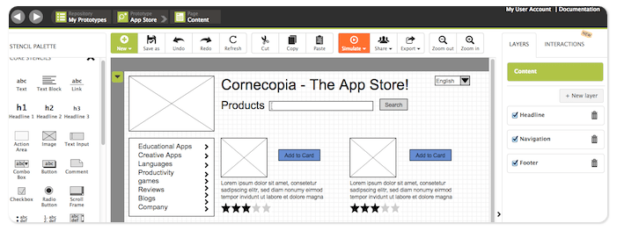
Image via pidoco
At this stage, you should have a pretty good idea about what your app will look like and what features you want to include. You should also have developed a scope of work—which pieces of the process will be performed in-house and which will be contracted out. Now it’s time to start sketching out your app and creating a storyboard.
There are many online tools for wireframing your app; your goal at this point is to develop a clear picture of how your ideas and proposed features will fuse together into a functional app. You should also create a storyboard, or roadmap, to demonstrate the connections between each screen and how users will navigate through the app. Keep these pointers in mind as you sketch:
- Look for opportunities to incorporate your brand.
- Focus on the user experience.
- Consider the differences in the way people use a mobile app versus a mobile website.

Defining the Backend of Your Mobile App
Your wireframes and storyboard will serve as a guide for the backend structures you’ll need to support your app—think APIs, data diagrams, servers, data integration, and push notification services. In many cases, SMEs find choosing a mobile backend as a service (BaaS) platform makes sense, since they solve common challenges such as scalability and lack of in-house talent.
One caveat: You may need to modify your wireframes and/or storyboard if you encounter technical limitations in the backend development process, so stay flexible at this early stage.

Finalize Your Wireframe and Test Your Prototype
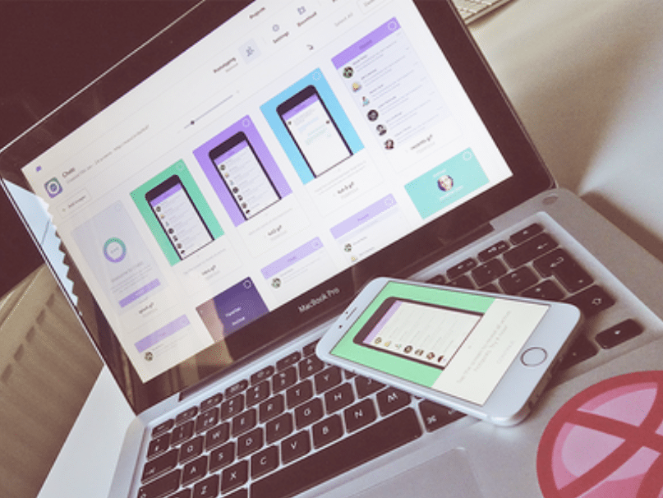
Image courtesy of Dribbble.com
At this point, you should nail down any changes in your wireframe identified during the backend planning process. Once your team has agreed upon the wireframe and storyboard, it’s time to build an interactive prototype.
Prototyping is an essential step in the app development process, because it gives you an opportunity to really evaluate design concepts, gather feedback, and identify dead links and flaws in the flow and usability of your mobile app. There are several good prototyping tools available online to simplify the process.
It’s a good idea to bring in people who are not part of your mobile app team to test and evaluate your prototype. Observe them as they interact with the app and ask for honest feedback on the app’s overall functionality and ease of use. Adapt the UI/UX to correct for any shortcomings identified during this stage.
Your goal is to finalize your app design concept and create a high fidelity prototype that will guide you through the actual app development process.

Developing the App
Actually developing the app involves a number of steps and processes. If you aren’t using an app development platform or mobile BaaS provider, your developer will have to set up the actual storage solutions, databases, APIs, and servers for the backend of your app.
Don’t forget to set up developer accounts for the app stores you plan to use to distribute your app, if you don’t already have them; this step can take several days to complete and is easy to overlook. It’s also a good idea to read through the app store guidelines so your app isn’t rejected during the review process.
You’re now ready to move into the programming and coding phase. If you’ve hired outside talent to develop your app, be sure to get a signed non-disclosure agreement and establish a timeline for deliverables. Keep in mind the “hire slow, fire fast” maxim and give yourself a quick out if you aren’t pleased with your programmer’s capabilities after the project starts.
At this stage, your designer will create the app “skins,” or actual screens used in your mobile app. These high-resolution renderings of your wireframes represent the interface your users will eventually use to interact with your app, so make sure your designs incorporate all the ideas and feedback collected during the earlier testing phase. After all, you are creating an app you want your customers and target audience to actually enjoy using, so UI/UX details matter.

Test and Test Again
This is an exciting time in the app development lifecycle—you finally have a complete app concept with exciting graphics and perfectly placed text. Now you need to rigorously test your app in a variety of real-world scenarios to sniff out and correct any technical flaws.
Go back to your original design and planning documents and go through every feature; don’t assume something works in the final concept just because it worked during the development phase.
Again, it’s a good idea to observe other users as they test the app—they may have questions and insights that aren’t obvious to you since you’ve been involved in app development since the earliest days. You may even want to use one of the online mobile UX testing tools that give you real-time feedback and analytics; several work on a freemium model that is cost effective for SMEs. Be sure to test for cross platform compatibility of images, graphics, and user experience.
When you’re confident your app is working correctly in all scenarios and you’re happy with the appearance and usability of the interface, it’s time to make the final preparations to launch your mobile app.

Preparing for Launch

The steps you take to prepare for your app launch may have the greatest effect on its ultimate success, and getting your marketing department involved early in the process is one of the most important. Marketing will help you with keyword research, which is essential for SEO and app store optimization (ASO), both of which are key for discoverability.
Your market and keyword research will guide your choices for app titles and descriptions as you prepare to submit your mobile app to the various marketplaces for distribution. You’ll also want to get high-quality screenshots of your app and maybe even a promotional video and/or demo at this point.
You’ll also need a website—or at least a landing page—to support and promote your app. This is important for branding and awareness, and also for search and discoverability; Google’s App Indexing API uses content within your app and your app’s web page in its search results algorithm. Key components of your app’s landing page or website should include:
- your app’s name and icon
- badges and names of the stores where your app can be downloaded
- screenshots and your promotional video
- a mailing list/subscription form (pre-launch) and download links (post launch)
- contact and support information
- links to your social media accounts
- a press kit
- testimonials and user reviews (post launch)
Be sure to promote your app on your business website and on your social media accounts; if you have a company blog, publish updates throughout the development process to create interest and anticipation. It’s also a good idea to launch an email campaign. Depending on your market niche and the type of app you are building, you may also want to enlist the help of experts and social influencers to help promote your app.
As you walk through your app promotion checklist, don’t forget to include app analytics to help you optimize your app and increase its appeal to your target audience. Google Analytics is a good place to start.
Now is also a good time to consider alternative app marketplaces, aside from Apple’s App Store and Google Play, to distribute your app. Another option to consider during the pre-launch phase is submitting your app to PreApps, an app marketplace that connects developers with early adopters, for some pre-release feedback.

Official Release
Your official release date should represent the climax of your app marketing efforts up to this point. It’s time to create some buzz with write-ups and articles by influential bloggers and journalists—and to make an announcement to everyone who showed interest in your app prior to launch. Promote your release with an email blast and mentions (with links) on all your social media profiles. The idea is to generate downloads and ratings, and build some momentum.
Don’t rest on your laurels once your app is released; you want to keep your new users engaged. This is a great time to use push notifications to announce a special offer or promotion so users will open your app. Consider offering incentives such as a one-time discount or free product or service for customers who download your app. Remember that marketing your app is an ongoing process, and your release-date efforts are just the beginning.
Finally, have a clear channel for feedback and be responsive to the comments and concerns of your users; a timely update or fix can work wonders for retaining your customers. Pay attention to your analytics and track those KPIs that define success for your marketing objectives.
Once you understand the key processes and steps in the mobile app development lifecycle, you’ll be better prepared to develop an app with the function and features you need—on a budget and timeline you can comfortably manage.

- Survey – Online , Door To Doo

Advantages
The advantages of a door-to-door survey are as follows: a surveyor shows a product or its photos to make questions; high confidentiality is maintained since the product can be withdrawn from a respondent without fail.

Others
The deliverables can be delivered in any language if required.
Extensive Respondents
Consumer survey includes not only online survey using the Internet but offline survey to respondents. An right survey/research method is selected; for example, an offline survey is used for acquiring data widely from seniors in general or direct responses from children. It is also available to obtain paired data by a survey on the differences between generations in a family. Furthermore, researchers review actual responses one by one to reject inappropriate responses for ensuring the quality of a survey.

- Digital Marketing – Whats Up, Facebook, Google
- CGD – City Gas Destitution Customer Billing
- Payment Collection
- Tracing & Denelofement – Railway
- Online Education Program
- Manipuri Sofofory

is a team of web strategists, designers and developers that turn sites & eCommerce stores into beautiful, high-converting, profit machines.

